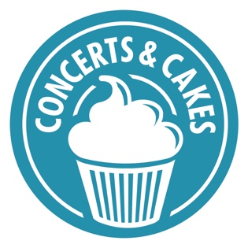

CONCERTS AND CAKES
LIVE MUSIC NOW IN THE COMMUNITY
Live Music Now offers interactive live music sessions presented by trained, talented professional musicians. With many years’ experience of delivering in care settings for older people, we provide accessible one-off concerts in the community, as well as our core residencies and projects.
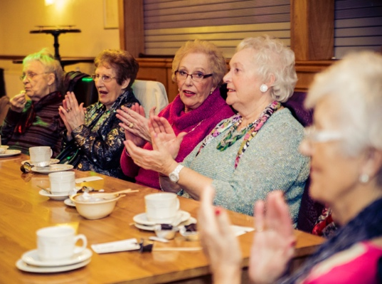
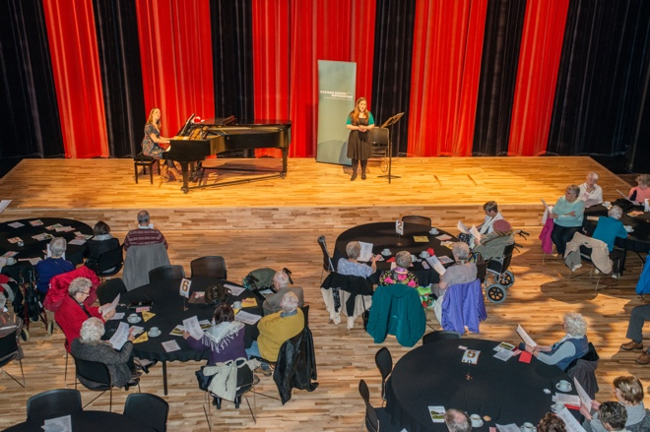

What is Concerts and Cakes?
Concerts and Cakes is a regular live music and social event for older people living in the community, including those in care, as well as their friends, family and carers. Each event provides a forum for the sharing of live music and includes a performance delivered by young professional musicians on the Live Music Now scheme, as well as the opportunity for making friends and building relationships, whilst enjoying tea and a slice of cake!

The musicians are not only expertly talented, but also specifically trained to work with vulnerable audiences, in particular with people living with dementia, disabilities and additional needs. This enables us to advertise Concerts and Cakes as Dementia Friendly and accessible to all.

Conversations between the musicians and the audiences, as well as feedback gathered from host venues informs the content of each event, as music suggestions are learnt, arranged and incorporated into the repertoire, offering a cultural exchange and a shared ownership of the programme

What difference does it make?
“Two friends and I have been attending these Concerts in the Coliseum Aberdare for a few
years now. We hardly ever miss one. We are all retired, but thankfully in good health, and
always look forward to the concerts. We never know until we turn up who the musicians
are going to be but they are all excellent. We can’t quite believe that we pay such a small
amount to be entertained by such wonderful professional musicians.
Sitting there for that hour, surrounded by live music, we are able to be transported to a
different place, where our cares and worries slip away, where we can be young/free/happy
once again. Sometimes we laugh, sometimes we cry, but we always leave feeling uplifted.
Thanks to you, and to all your musicians for allowing each of to get lost in the music.”

- Judith Langdon, participant.

With the number of older people across the UK set to rise dramatically, there is an urgent need to tackle social isolation and ease challenges faced by the oldest members of our society. A recent report found that nearly one-fifth of over 75’s “felt lonely much of the time during the past week” and whilst a quarter of 65 -74 year olds live alone, nearly half of over 75’s do so.1 Nick Pearce, Director of the Institute for Public Policy Research, said: “For too many people, growing older is a journey of loss – losing work, mobility and friendships.”

“Presenting the music in the form of a social event (and giving the group an active choice of repertoire) provides a setting conducive to sharing and discussion. It is now widely recognised that participation in such activities is an excellent catalyst to contributing to making new friends, acquiring new knowledge and to feeling more useful and optimistic in life.
Our high-quality interactive music sessions are more than ‘entertainment’ as they promote social interaction, creativity, feeling engaged with life and connecting with self and emotions which have positive effects on, social, intellectual, emotional and spiritual wellbeing. Sessions can provide participants with a collective focus and an outlet for their creative energy. It is increasingly recognised that involvement in arts initiatives ‘may be particularly important in counterbalancing the mental wellbeing difficulties associated with periods of loss which can increase the risk of low mood, anxiety and social isolation.”2
There is a growing body of evidence that live music offers real benefits to how people feel part of and connected to their community. Our own feedback and evaluation of our Concerts and Cakes programme shows us that it contributes to:
- Reduced loneliness and unwanted isolation, building social networks and communities of support;
- Increased engagement with the world;
- Enjoyment and happiness in the moment in addition to improvement in mood over time; and
- Personal and cultural development through interacting meaningfully with lively, stimulating professional performers.

1 1 Is 75 the new 65? Published: 19 October 2011 by Institute for Public Policy Research with funding from City Bridge Trust.
2 An Evidence Review on the Impact of Participatory Arts on Older People, published September 2011 by Mental Health Foundation commissioned and funded by the Baring Foundation.
Project Delivery
The following core elements underpin all delivery:
- intergenerational work, encouraging young musicians and older people to connect and relate to one another;
- enabling people to fully participate with ease because of the training offered to LMN musicians and their interactive style;
- being 'person centred' – musicians and staff getting to know participants better and helping them to connect with each other as their musical knowledge, skills, preferences, reminiscences and pleasure all come to the fore
- opportunities for participants to socialise with each other and make new friendships, creating community and combatting loneliness
Each session;
- maximizes active engagement – with the music, musicians, staff and fellow audience members;
- offers flexible programming led by the needs and choices of the older group;
- creates ways of facilitating meaningful participation.
Concerts and Cakes currently runs at various community and arts venues across Wales, including The Coliseum in Aberdare, The Lyric Theatre and Y Ffwrnes in Carmarthenshire, The Riverfront in Newport and Mid Wales Pavilion in Llandrindod Wells. We have also successfully completed Concerts and Cakes as a pilot project in Memo Arts Centre in Barry, Octavo’s Book Café in Cardiff Bay and various Cardiff Council Community Hubs.
Funding from Arts Council of Wales, ICF Dementia Friendly Communities, The Utley Foundation, Community Foundation in Wales, The Bernard Piggott Trust, The Oakdale Trust and Wrexham County Borough Council Community Inclusion Grant has enabled us to increase the reach of Concerts and Cakes, impacting the lives of many older people across Wales. Concerts and Cakes is also supported by Age Cymru and Dementia Friends.
About Live Music Now
Live Music Now is a UK-wide charity set up in 1977 by renowned violinist Yehudi Menuhin and his friend Ian Stoutzker. The charity retains Menuhin’s vision of offering the benefits of live music to those with least access to it, as well as supporting and helping to further develop talented professional musicians at the start of their careers. Each year, LMN delivers around 2,500 music sessions in community settings across the UK, with up to 450 in Wales.

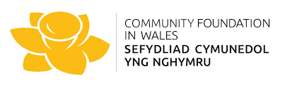
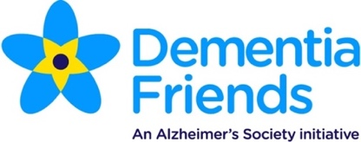
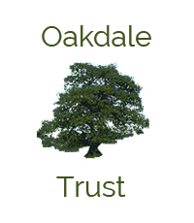
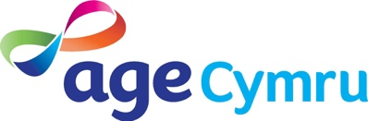
THE BERNARD
PIGGOTT TRUST
ICF DEMENTIA
FRIENDLY COMMUNITIES

